Calculating Family Expenses Using Service Now

ServiceNow Team ID : NM2025TMID04659
Team Size : 4
Team Leader: Manusha B.M
Team member: Muthu Selvi S
Team member: Nega S B
Team member: Neha R

  - Problem Statement
In a project of managing family expenses is often challenging due to the lack of a centralization system for tracking income, expenses, and savings. Families typically rely on manual methods such as spreadsheets, paper records, or multiple apps, which can lead to errors, duplication, and difficulty in analysing financial patterns.

  - Objective
Simplify Expense Tracking- provide a centralization system for recording and categorising all family expenses
Improve Financial Awareness-offer real-time dashboards and reports to give clear insights into spending patterns
Enhance Budget Planning-support better financial planning by identifying high-spending categories and opportunities to save

Skills: Servicenow Development, Workflow&Automation, Scripting in Servicenow,Reporting&Dashboards, Integration Skills

  - TASK INITIATION

Update
  - Activity 1:
1.Open Service now
2.Go to All>>search for Local Update Set>Click on New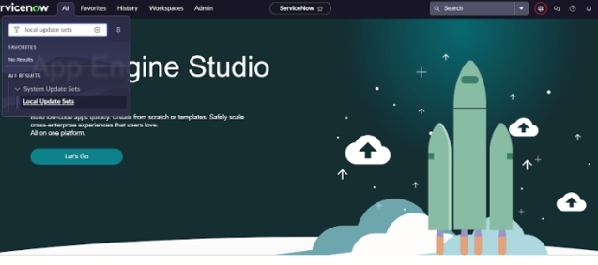
3. Enter the Details as:
Name: Family Expenses
4. And then click on Submit and make current
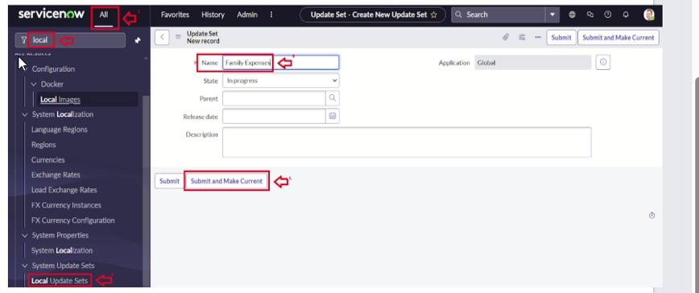

Table
  - Activity 2:
1. Open Service now
2.Go to all>search for Tables>Click on New
3.Enter the Details:
Label:Family Expenses
Name: Auto-Populated
New menu name: Family Expenditure
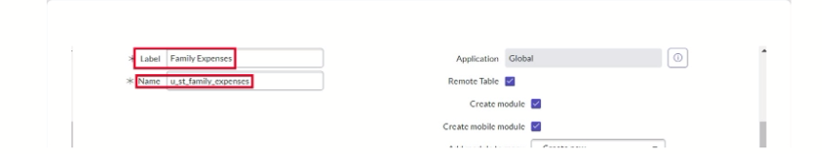
4. Click on save

  - Activity 3:
1. Open Service now
2. Near Columns Double-click near insert a new row
Give the details as:
Column label: Number
Type: String
3. Double-click on insert a new row again
Give the details as:
Column label:Date
Type:Date
4.Double click on insert a new row again
Give the details as:
Column label:Amount
Type:Integer
5 .Double click on insert a new row again
Give the details as:
Column label:Expense Details
Type:String
Max length:800
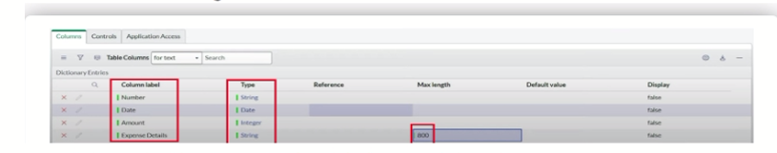
6.Click on save

  - Activity 4:
1.Open Service now
2.Double click on the Number field/Column
3.Go down and double click on Advanced view
4.In Default Value:
Use dynamic default:check the box
Dynamic default value:Get Next Padded Number
5.click on update
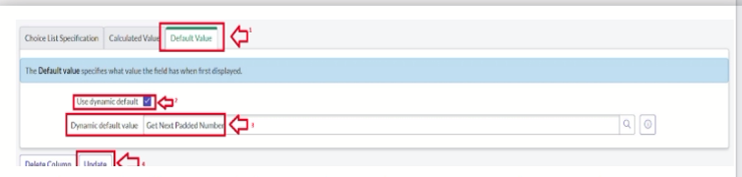
6.Go to all>>search for Number Maintenance>>select number maintenance
7.click on new
8.Enter the details:
Table:Family Expenses
Prefix:MFE
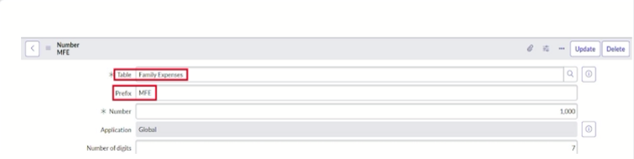
8.Click on Submit

  - Activity 5:
1.Open Service now
2.Go to all>>search for Family Expenses>>Open family Expenses
3.Click on new
4.Go to header and click there>>click on configure>>Select Form Design
5.Drag Drop the form as requirement
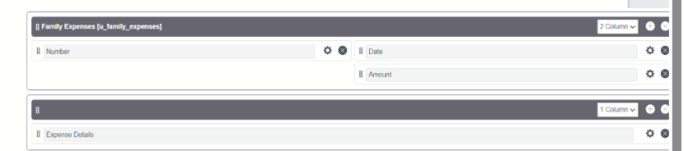
6.Make Number Read-Only Field by Clicking
7.Make Date,Amount Mandatory field by Clicking
8.Click on save

Table(Daily Expenses)
  - Activity 6:
1. 1.Open Service now
2.Go to all>search for Tables>Click on New
3.Enter the Details:
Label:Daily Expenses
Name:Auto-Populated
Add Module to menu :Family Expenditure
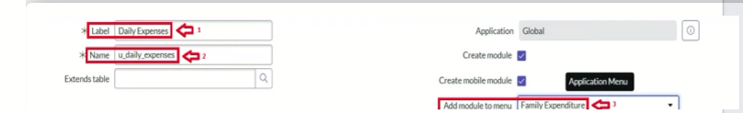
4.click on save

  - Activity 7:
1.Open Service now
2.Near Columns Doubl;e Click near insert a new row
Give the details as:
Column label:Number
Type:String
3.Double click on insert a new row again
Give the details as:
Column label:Date
Type:Date
4. Double click on insert a new row again
Column label:Amount
Type:Integer
5 .Double click on insert a new row again
Column label:Expense Details
Type:String
Max length:800
6.Double click on insert a new row again
Give the details as:
Column label:Comments
Type:String
Max length:800
6.Click on save

  - Activity 8:
1.Open Service now
2.Double click on the Number field/Column
3.Go down and double click on Advanced view
4.In Default Value:
Use dynamic default:check the box
Dynamic default value:Get Next Padded Number
5.click on update
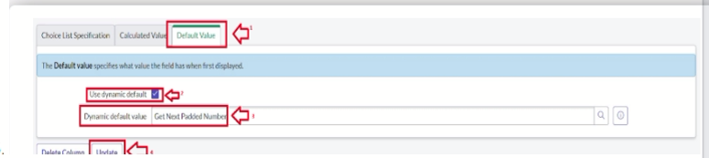
6.Go to all>>search for Number Maintenance>>select number maintenance
7.click on new
8.Enter the details:
Table:Daily Expenses
Prefix:MFE
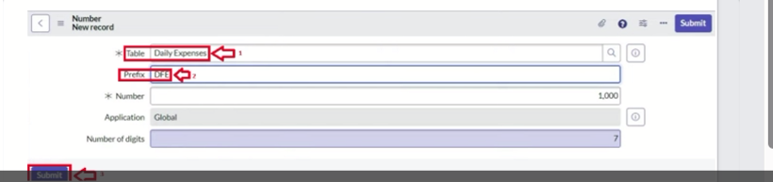
9.click on submit

  - Activity 9:
1.Open Service now
2.Go to all>>search for Daily Expenses>>Open Daily Expenses
3.Click on new
4.Go to header and click there>>click on configure>>Select Form Design
5.Drag Drop the form as requirement
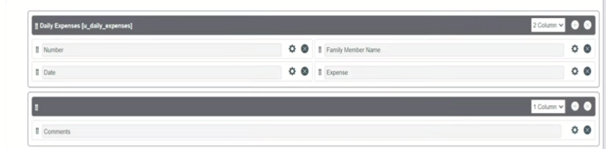
6.Make Number Read-Only Field by Clicking
7.Make Date,Family Member Name Mandatory field by Clicking
8.Click on save

Relationship
  - Activity 10:
1.Open Service now
2.Go to all>>search for relationships>>open relationships
3.click on new
4.Enter the details:
Name:Daily Expenses
Applies to table:select Family Expenses
Daily Expenses:select Daily Expenses
5.click save

Configuring Related List
  - Activity 11:
1.open Service now
2. .Go to all>>search for Family Expenses>>Open FamilyExpenses
3.Click on new
4.Go to header and click there>>click on configure>>select Related Lists
5.Add Daily Expenses to selected area
6.click on save
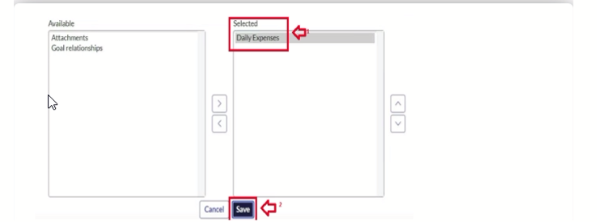

Business rule
  - Activity 12:
1.Open Service Now
2.Go to all>>search for Business Rules
3.Under system definition select business rules then click new
4.Enter the Details:
Name:Family Expenses BR
Table:Select Daily Expenses
Check Advanced
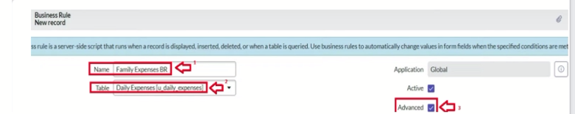
5.In when the run check insert and update
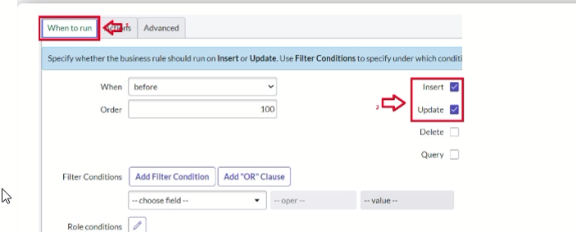
6.In Advance(we write the code)
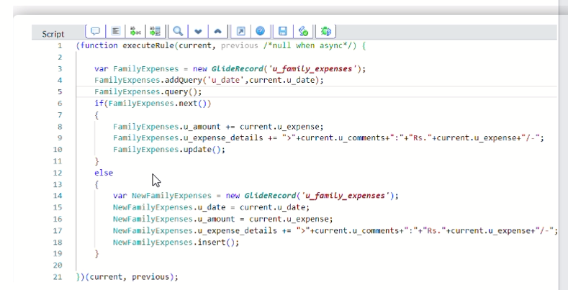
7.click on save

Configure The Relationship
  - Activity 13:
1.Open Service now
2.Go to all>>search for relationships>>open relationships
3.In open Daily Expenses relationship
For Applies to table:select Family Expenses
In Query with:write the below Query
4.click on update

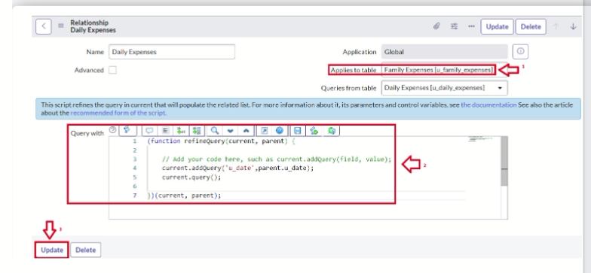

Conclusion
The Family Expense Calculation System developed on Service Now provides a centralized, automated, and user-friendly platform for managing and tracking household expenses. By leveraging ServiceNow’s capabilities, users can record, categorize, and analyze expenses in real time, ensuring better financial planning and transparency. The system not only simplifies routine expense tracking but also helps families identify spending patterns, plan budgets effectively, and make informed decisions.
Overall, the project demonstrates how automation and digital platforms like ServiceNow can be effectively utilized to streamline personal finance management, making it accurate, efficient, and accessible.

